00d- Sprint Information and Retrospective

Part One: Task Management Board
Team number: Group 12 |  | Sprint number: Sprint 1
Link to Scrum Board: https://trello.com/invite/b/69f1252414c3094e343d62fe/ATTI08c02146cbf06f985e835fed3d7d8b55340072F9/-

Sprint Goal: By the end of this sprint, we will have the UI for our app done and the main question flow completed and easy to follow.

Tasks Planned: 46 | Tasks Completed: 45 |  |  |  | Tasks Carried Over: 1
"Sprint Done" column:
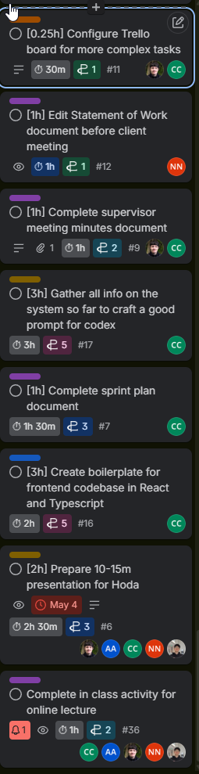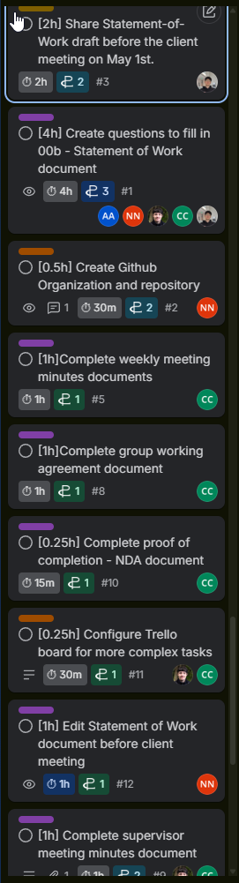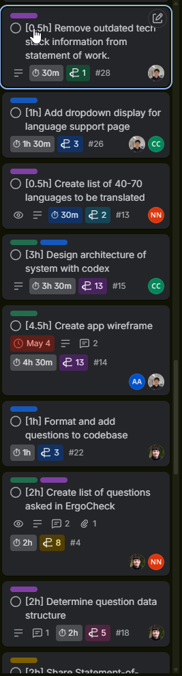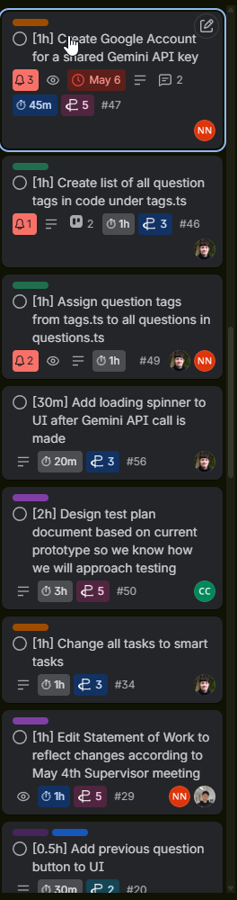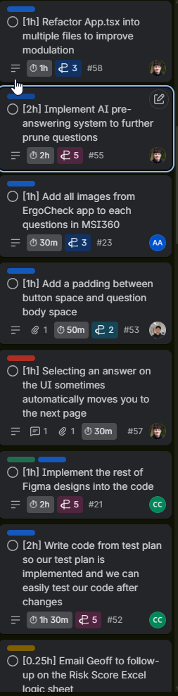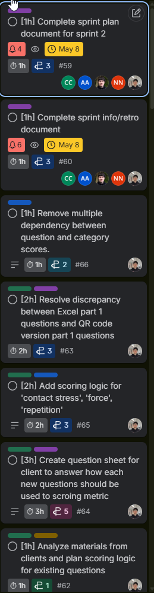

Part Two: Estimates and Actuals

Team Member | Estimated Work | Actual Work on Sprint | Variance (+/-) | Root Causes +  One-Sentence Explanation
Cole | 24 hours | 22 hours | -2 hours | - We had some criteria which was not clear for one of our tickets, causing some overlap where one was already completed.
Nicholas | 16 hours | 16.5 hours | +0.5 hours | - Underestimated the time it takes to complete the ticket.
Jonah | 22.75 hours | 18 hours | -4.75 | - Overestimated the amount of time a ticket would take
Abdullah | 14.5 hours | 16.5 hours | + 2 hours | - Some docs and preparation tasks took longer than expected
Kyle | 40 hours | 29 hours | - 11 hours | - Some code work and documentation jobs could be sped up by utilizing AI and client being very responsive
Total | 117.25 hours | 102 hours | - 15 hours | - We were still getting used to estimations for this sprint.

Part Three: Retrospective

Individual:

1. What Went Well, appreciations, positive notes, etc
Name | Answer
Cole | Team meetings went a lot smoother than previous week, we felt a lot more organized overall.
Jonah | All major work was completed on time, the app is functioning well, and the client was pleased with our progress.
Abdullah | The design and planning work went well. The wireframe gave the team a clearer direction for the app's layout and made it easier to agree on the structure before starting implementation.
Nicholas | We were able to work through some of our harder problems (ie: AI/question pruning) this sprint as a team, which was very rewarding.
Kyle | We were able to spark an interesting discussion with the client, which inspired both sides to think about how we could integrate AI into our original plan.

2. What Could Be Improved, noteworthy, needs change, etc
Name | Answer
Cole | I had to miss one of our client meetings.
Jonah | We had one small ticket carry over.
Abdullah | I should check for technical issues before the meetings.
Nicholas | I should pay more attention to the parts of the system the other team members are working on.
Kyle | I had to organize some of the feedbacks from clients better to better communicate with the client and team.

3. Actions for Improvement, next steps, etc
Name | Answer
Cole | Put more time into dividing tickets based on who is assigned to each epic.
Jonah | Spend more time planning tickets within our sprint planning meeting.
Abdullah | Test everything before meetings and be ready to show my work clearly
Nicholas | Ask more questions to other team members about the features they are working on in our standup meetings.
Kyle | Organize the client’s feedback into a structured question-answer sheet.

Team:

5. Lessons Learned
- We learned about the subject matter of the project (ergonomics), which helped us better understand our goal.
- We learned to better divide our tickets into epic categories for next sprint.

6. Commitments for Next Time
- We will take more time creating sub tickets for each epic so each ticket has a clear epic it relates to and each member can work on related tasks.
- We will change epics to be user stories.

